**Backend Engineering - I**

Project Report

Semester-IV (Batch-2023)

**Club Verse**



**Supervised By: Submitted By:**

Ms. Shinnu Jangra Aaryushi (2310991588)

Akhil Handa (2310991598)

Anmol Singh (2310991609)

Ansh Vohra (2310991611)

**Department of Computer Science and Engineering**

Chitkara University Institute of Engineering & Technology,

Chitkara University, Punjab

**ABSTRACT**

**Project Title :**

“Club Verse”

**Introduction :**

Club Verse is an innovative web-based nightlife discovery platform designed to connect users with the best bars, events, and live entertainment around them. The project addresses the common challenge of finding personalized, up-to-date nightlife information in a seamless and user-friendly way. Built using modern web technologies including HTML, CSS, JavaScript, Node.js, and Express.js, Club Verse delivers real-time event updates, personalized recommendations, and user reviews to enhance every night out. With features such as interactive dashboards, location-based bar discovery, exclusive deals, and a secure login system, Club Verse redefines how users plan and experience nightlife. This project highlights the potential of digital platforms to enrich social experiences by bringing convenience, community, and excitement into the palm of your hand**.**

**TABLE OF CONTENTS**

1. Introduction
2. Problem Definition and Requirements
3. Proposed Design and Methodology
4. Results
5. References

**1. INTRODUCTION**

### **1.1 Background**

Nightlife culture has evolved significantly with the advent of digital platforms, but there remains a gap in centralized, user-friendly tools for discovering and engaging with real-time nightlife options. People often rely on word-of-mouth or scattered online sources to learn about bars, events, and live performances. This fragmentation can make planning a night out inefficient and overwhelming.

***Club Verse*** is designed to bridge this gap by offering a comprehensive, web-based platform where users can explore nearby bars, receive personalized recommendations, and stay updated with ongoing or upcoming events. It streamlines the process of nightlife planning into a single, accessible interface, improving the experience for both users and nightlife businesses.

**1.2 Objectives**

The primary goal of Club Verse is to provide a modern, user-friendly platform for discovering nightlife venues and events. This section elaborates the objectives into specific sub-goals:

**1.2.1 User-Centric Experience**

* To design a platform that prioritizes user convenience through an intuitive UI.
* To make it easier for users to find nearby bars and events with minimal effort.
* To offer a seamless browsing experience on both desktop and mobile devices.

**1.2.2 Real-Time Updates**

* To provide users with real-time information about events, special offers, and live performances.
* To ensure that all event data is kept up to date, enhancing the reliability of the platform.

**1.2.3 Personalized Recommendations**

* To implement logic for personalized suggestions based on users’ preferences and past interactions.
* To analyze user behavior and browsing history to tailor recommendations for bars and events.

**1.2.4 Engagement and Interaction**

* To allow users to leave reviews and ratings, thereby building a community-driven platform.
* To offer a space where users can share their experiences and help others make informed decisions.

**1.2.5 Integration of Business and Users**

* To bridge the gap between nightlife businesses and potential customers by providing a promotional platform.
* To allow bar owners and event organizers to update listings, promote events, and offer deals directly through Club Verse.

**1.3 Significance**

Club Verse is not merely a discovery tool—it represents a shift in how people experience nightlife through digital engagement. Its significance is detailed below:

**1.3.1 Enhancing the Nightlife Experience**

* Club Verse simplifies how users explore nightlife by consolidating venue details, events, ratings, and deals into one interface.
* The platform transforms casual plans into informed, well-curated experiences, ensuring users make the most of their nights out.

**1.3.2 Promoting Local Businesses**

* Bars, clubs, and event venues often struggle with visibility in a crowded online space.
* Club Verse offers these businesses a direct channel to reach relevant, interested audiences without the need for expensive advertising.

**1.3.3 Use of Modern Web Technologies**

* This project showcases the effective use of full-stack technologies like Node.js, Express.js, and JavaScript for building scalable and responsive web applications.
* By implementing security measures (Helmet.js), rate limiting, and real-time updates, the project demonstrates industry-standard practices.

**1.3.4 Building a Connected Community**

* User-generated content such as reviews and ratings fosters a community of nightlife enthusiasts who support and guide one another.
* This social element increases trust and engagement on the platform.

**1.3.5 Academic and Professional Value**

* For developers, this project acts as a real-world application of key software development concepts including frontend-backend integration, user authentication, and dynamic data handling.
* It provides a strong portfolio example showcasing a complete web solution addressing a real-world problem.

**2. PROBLEM DEFINITION AND REQUIREMENTS**

**2.1 Problem Statement**

In today’s digital age, most social and recreational activities are being enhanced or facilitated by technology. However, despite the increasing popularity of web and mobile applications for travel, food, and shopping, the nightlife and entertainment sector still lacks a centralized, dynamic, and user-friendly digital platform tailored specifically for real-time event discovery and bar exploration.

Currently, people rely on a combination of social media posts, messaging groups, online forums, or generic map applications to find nightlife venues or events. This scattered information often results in:

* Outdated event details, such as canceled shows or expired offers.
* Lack of personalization, with no tailored suggestions based on user interests.
* Poor user experiences, due to unreliable reviews or limited venue information.
* Time-consuming planning, as users must visit multiple sources to compare venues or learn about events.

Moreover, nightlife businesses like bars and event organizers face significant challenges in promoting their services to a targeted audience. Advertising through mainstream platforms is often expensive and lacks the specificity needed to engage local or interest-based communities.

This disconnection between users seeking nightlife experiences and venues trying to reach potential customers creates a gap in the market. There is a clear need for a platform that brings together users and nightlife businesses in a meaningful, efficient, and interactive way.

Club Verse is proposed as a solution to this problem. It will serve as a centralized nightlife discovery platform that provides:

* Real-time updates about nearby bars and events.
* Personalized recommendations based on user behavior and preferences.
* A digital space for users to review and rate their experiences.
* A promotional channel for businesses to list events, deals, and updates.

By addressing the limitations of existing solutions, Club Verse aims to redefine how users interact with nightlife offerings and how businesses reach and engage their audience.

**2.2 Software Requirements**

**2.2.1 Frontend Technologies**

* **HTML5:** Provides the structure of web pages. Used to create semantic layouts, forms, and interactive elements.
* **CSS3:** Styles the application, ensuring visual consistency and responsiveness across devices.
* **JavaScript:** Powers client-side logic—navigation controls, event listeners, form validation, and dynamic content updates.
* **EJS (Embedded JavaScript Templates):** Enables server-side rendering of dynamic HTML pages by embedding JavaScript in markup. Facilitates reusable templates (header/footer/partials) and easy data binding from the Express backend.
* **Responsive Design Frameworks (Optional Enhancement):** Libraries such as Tailwind CSS or Bootstrap can be integrated for mobile-first design and rapid prototyping.

**2.2.2 Backend Technologies**

* **Node.js:** Node.js is a JavaScript runtime environment that allows server-side scripting using JavaScript. It enables asynchronous processing, making the application responsive and efficient. In Club Verse, Node.js is used to manage server logic and handle file-based data.
* **Express.js:** Express.js is a lightweight Node.js framework used to build web applications and APIs. It simplifies routing, middleware integration, and request handling. In this project, it manages page navigation, user requests, and API endpoints.

**2.2.3 Middleware and Node Modules**

**2.2.4. Database Technologies**

* **EJS MongoDB :** MongoDB is a NoSQL, document-oriented database. Stores all persistent data including users, artworks, orders, events**.**
* **Mongoose ODM :** Mongoose is an Object Data Modeling library for MongoDB and Node.js. Defines schemas and models for structured data access , validation, and relationships between entities**.**

**2.2.5 Data Models**

**2.2.6 External Data APIs**

**3. PROPOSED DESIGN AND METHODOLOGY**

The system architecture of Club Verse follows a client-server model using a layered architecture that separates concerns across the user interface, application logic, and data management components. This structure ensures maintainability, scalability, and modular development.

The server is built using Node.js and the Express.js framework, which handles HTTP requests, routes, business logic, and middleware integration. The client-side is constructed with EJS templates, which dynamically render HTML based on data received from the server. Static assets such as stylesheets, images, and client-side scripts are served from the public directory. Data is stored using lightweight .json files (e.g., users.json, events.json) instead of a traditional database.

The architecture also integrates essential middleware such as Helmet.js for security, CORS for cross-origin requests, express-rate-limit for abuse protection, and custom modules for logging (logger.js) and error handling (errorHandler.js). This approach ensures a secure and efficient web application that handles user interaction reliably.

The user interaction begins with the Login/Register interface, which acts as a gateway to the platform. This design ensures that all features—such as event access, bar listings, and personalized content—are available only to authenticated users.

After successful login, the user is directed to the Dashboard, where they can:

* Browse Bars: Discover local bars with descriptions, ratings, and live offers.
* Explore Events: View upcoming nightlife events with venue and time details.
* Access Personalized Recommendations: Receive suggestions based on preferences or browsing history.
* View & Submit Reviews: Read feedback from other users or submit their own.
* Book or Reserve Deals: Select and reserve spots for events or claim special offers.
* Logout Securely: End the session to protect user data.

This user-centric flow enhances usability by providing clear navigation paths and immediate access to relevant features.

To support modular and organized development, Club Verse follows a clean and scalable directory structure. This separation of logic enhances code readability and supports collaborative development.

* public/ contains all assets sent directly to the browser.
* views/ contains .ejs files for the login page, dashboard, bar/event details, etc.
* controllers/ manage core operations such as login handling and data rendering.
* models/ read/write user and event data from JSON files.
* middleware/ includes application-wide services like security and logging.

To build Club Verse, a range of modern technologies and tools are used, categorized as follows:

The incremental development model was followed to ensure continuous progress, iterative testing, and smooth integration of features. This methodology allowed for rapid prototyping and refinement based on user feedback.

Phase 1: Requirement Analysis

* Identified the need for a nightlife discovery platform with real-time updates, personalized recommendations, and booking functionality.

Phase 2: Design

* Created mockups, file structures, and diagrams including the system architecture, user flow, and component interactions.

Phase 3: Development

* Implemented core features starting with login, followed by dashboard integration, bar and event browsing, and review systems.
* Used modular development for routes, controllers, and data handling.

Phase 4: Testing

* Conducted unit testing and manual testing for login validation, page navigation, and data retrieval.
* Verified JSON read/write accuracy and UI responsiveness.

Phase 5: Deployment (Optional)

* Project runs on a local server using Node.js.
* Can be deployed to platforms like Heroku or Render for online access in the future.

**3.1 File Structure**

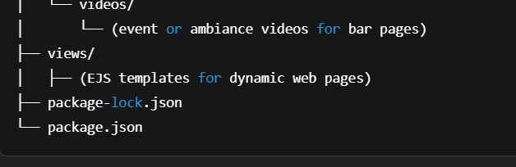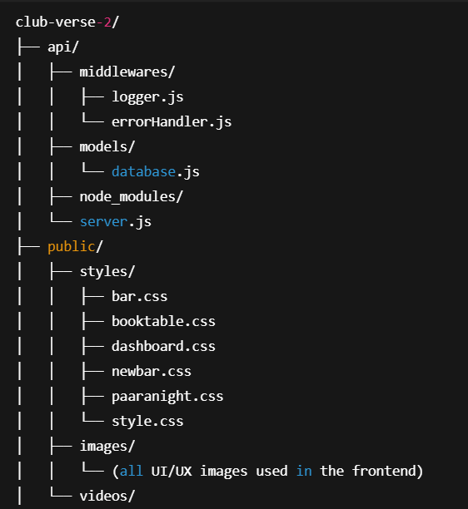

**3.2 System Architecture**

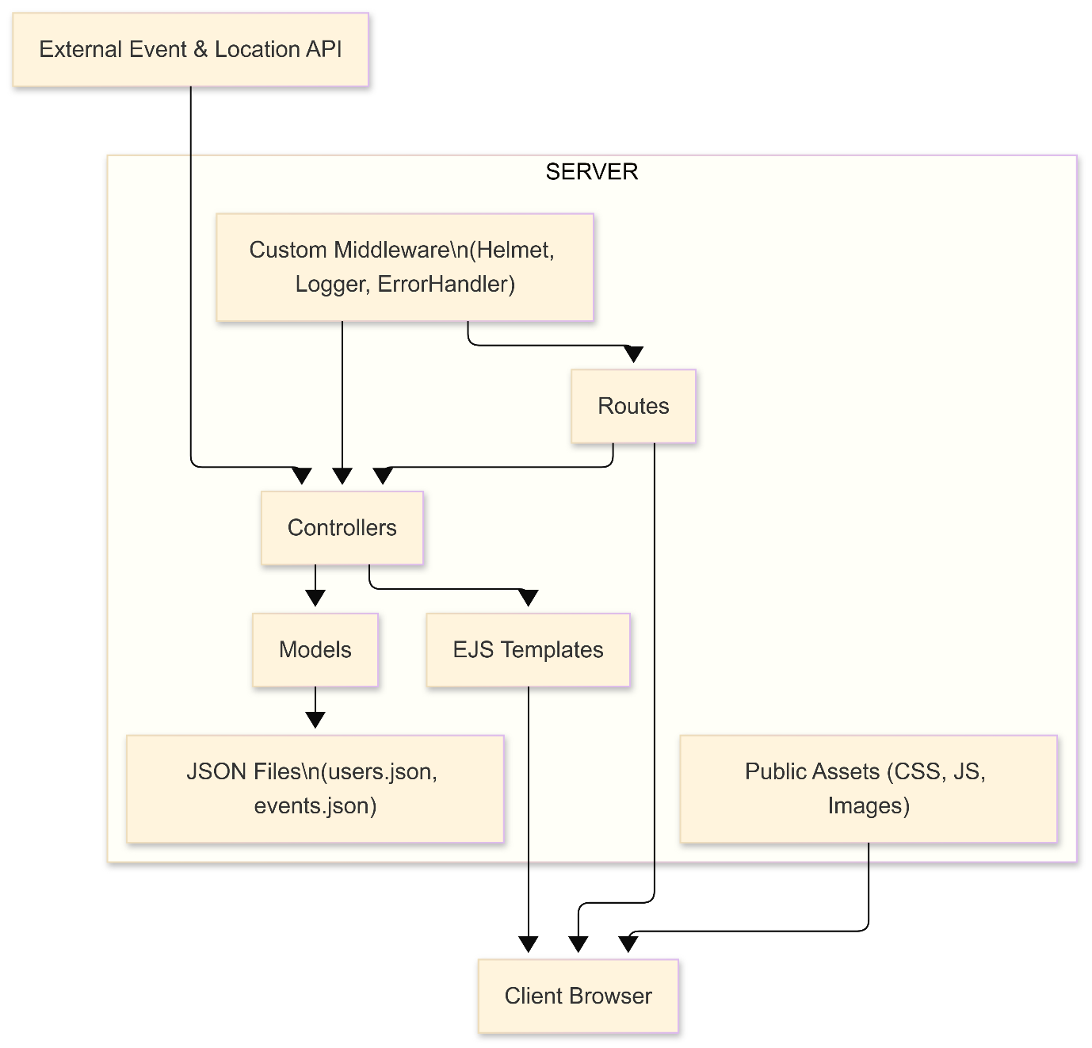

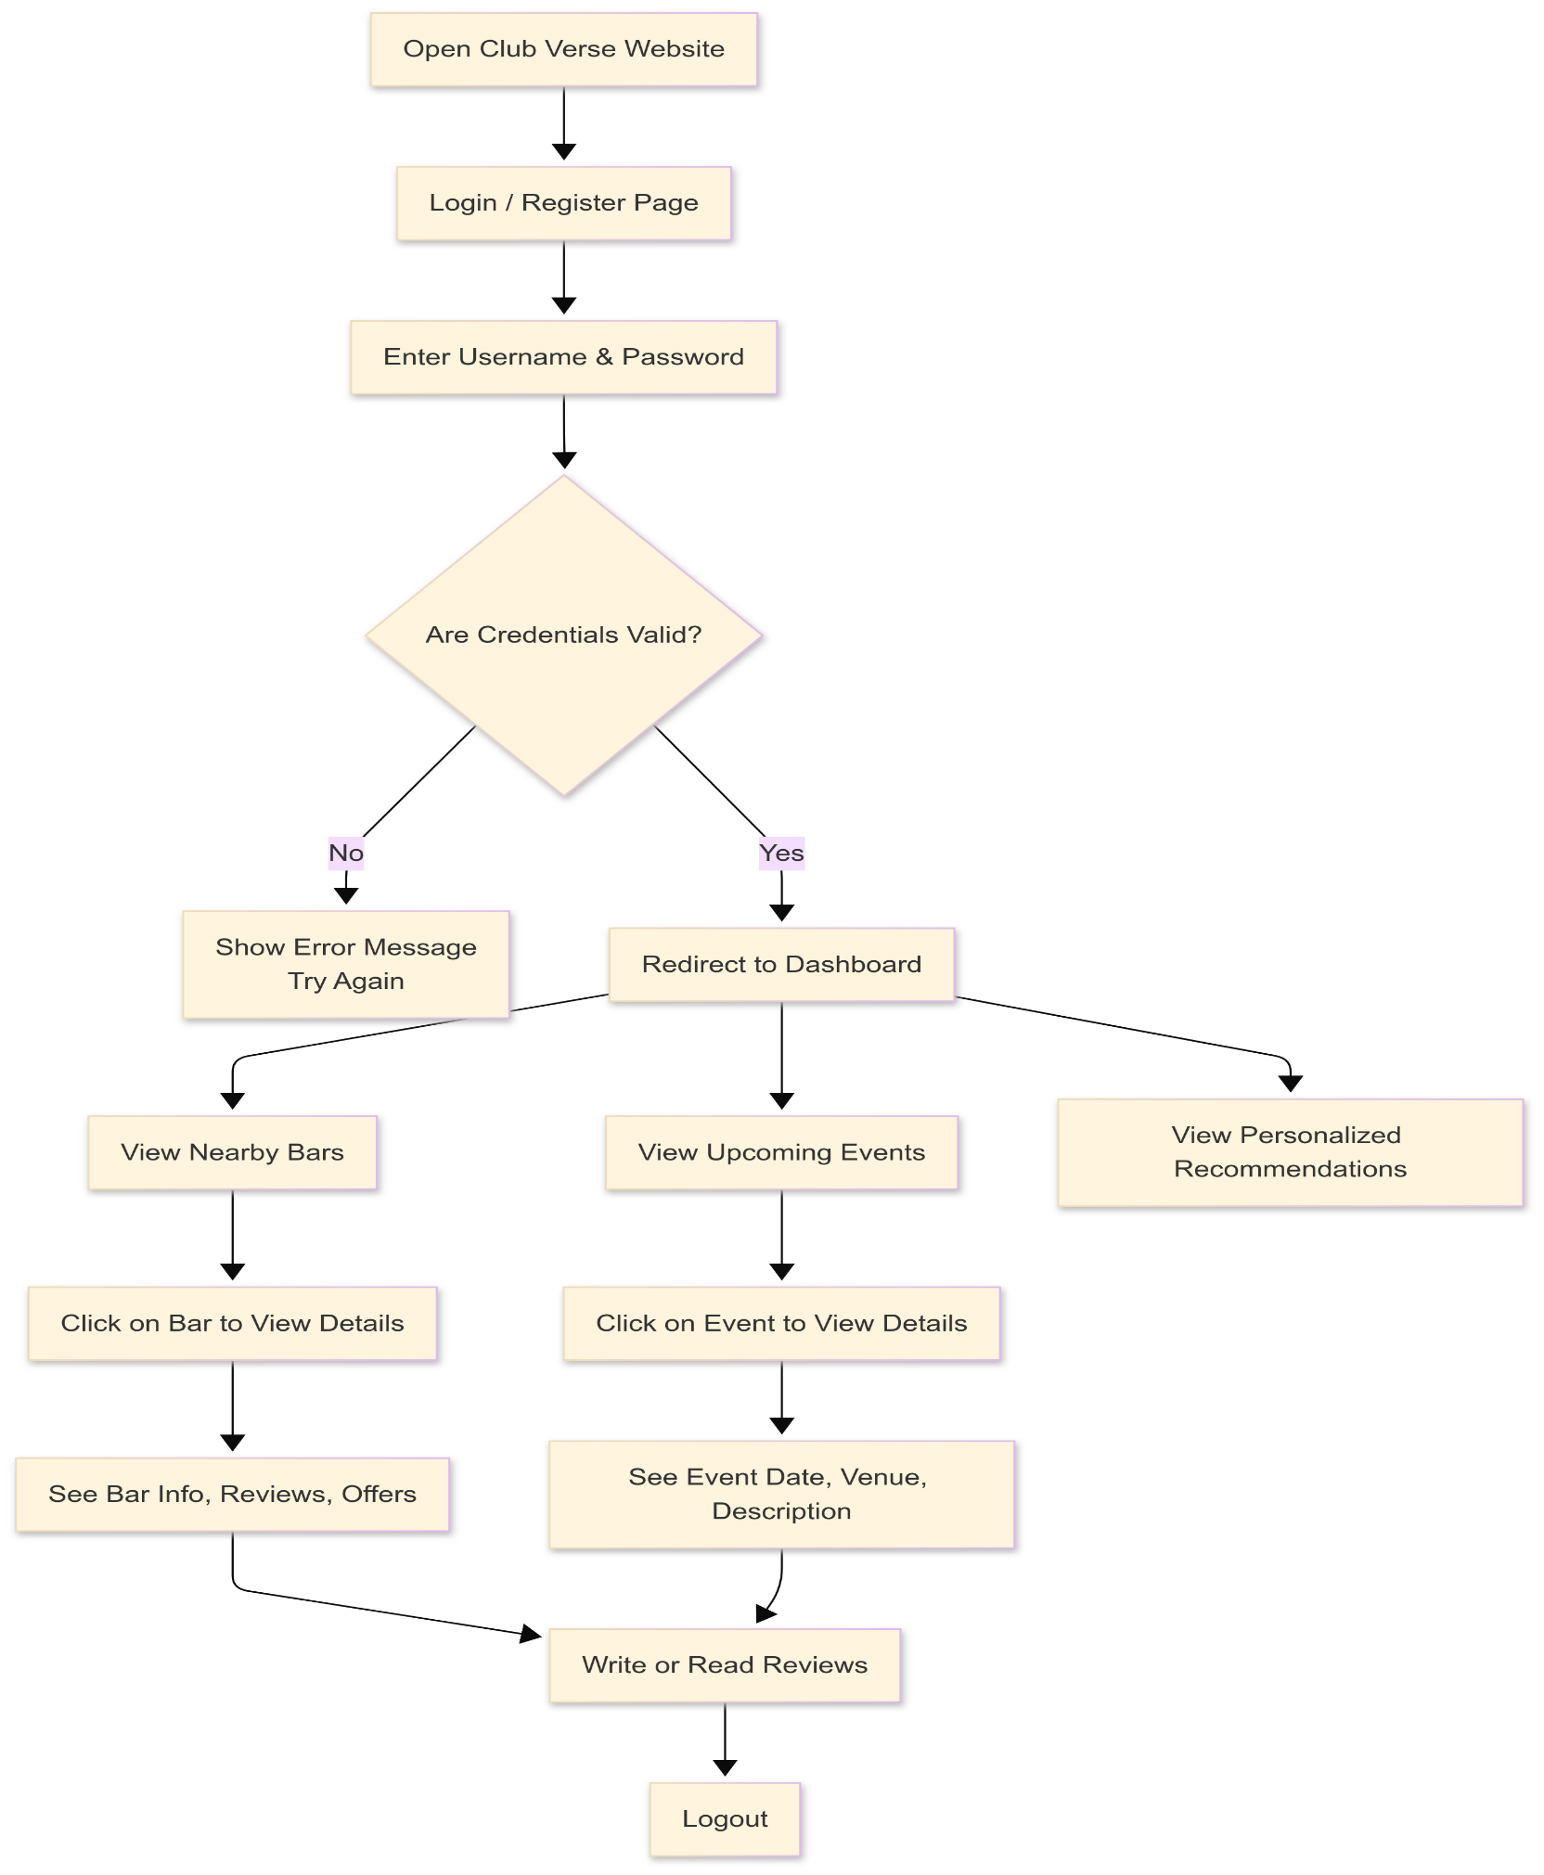**3.3 User Interaction**

**3.4 E-commerce Methodolgy**

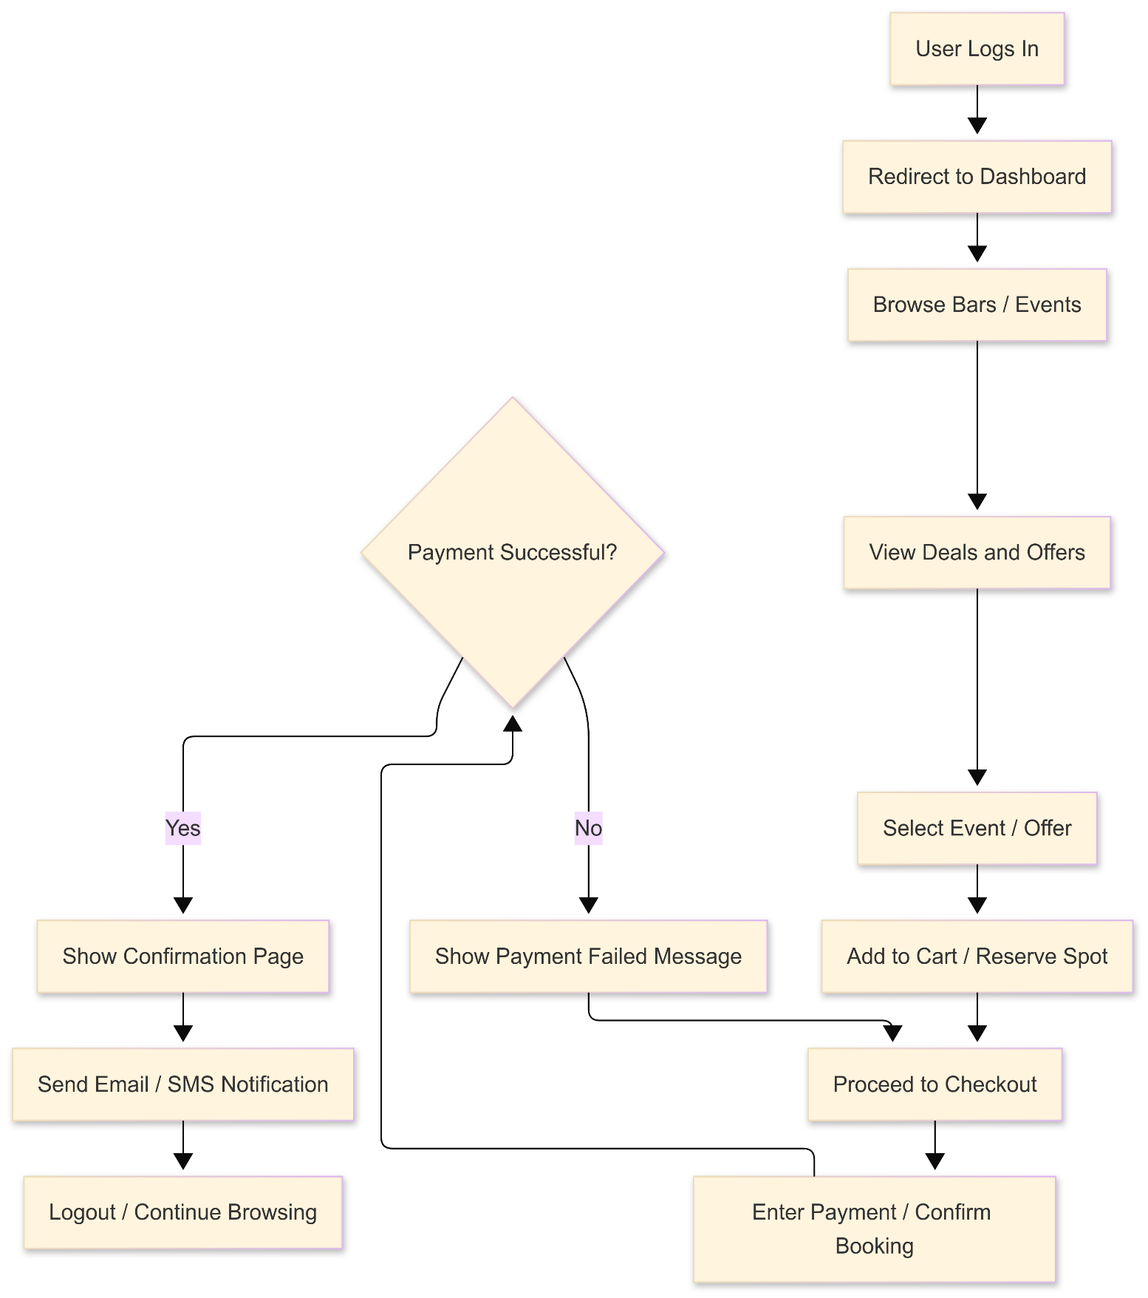

**4. RESULTS**

**4.1 login page**

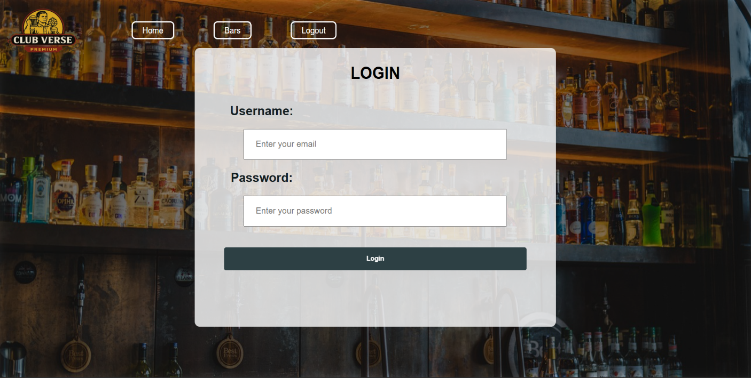

**4.2 Registration Page**

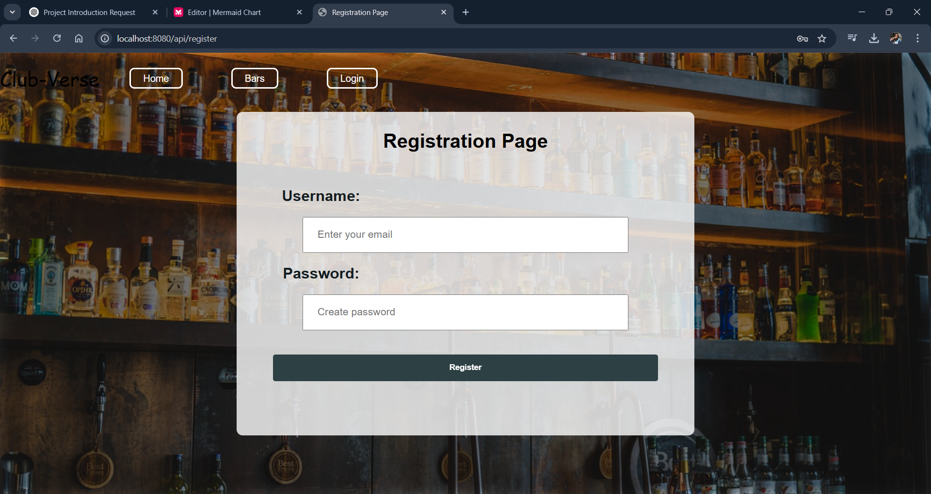

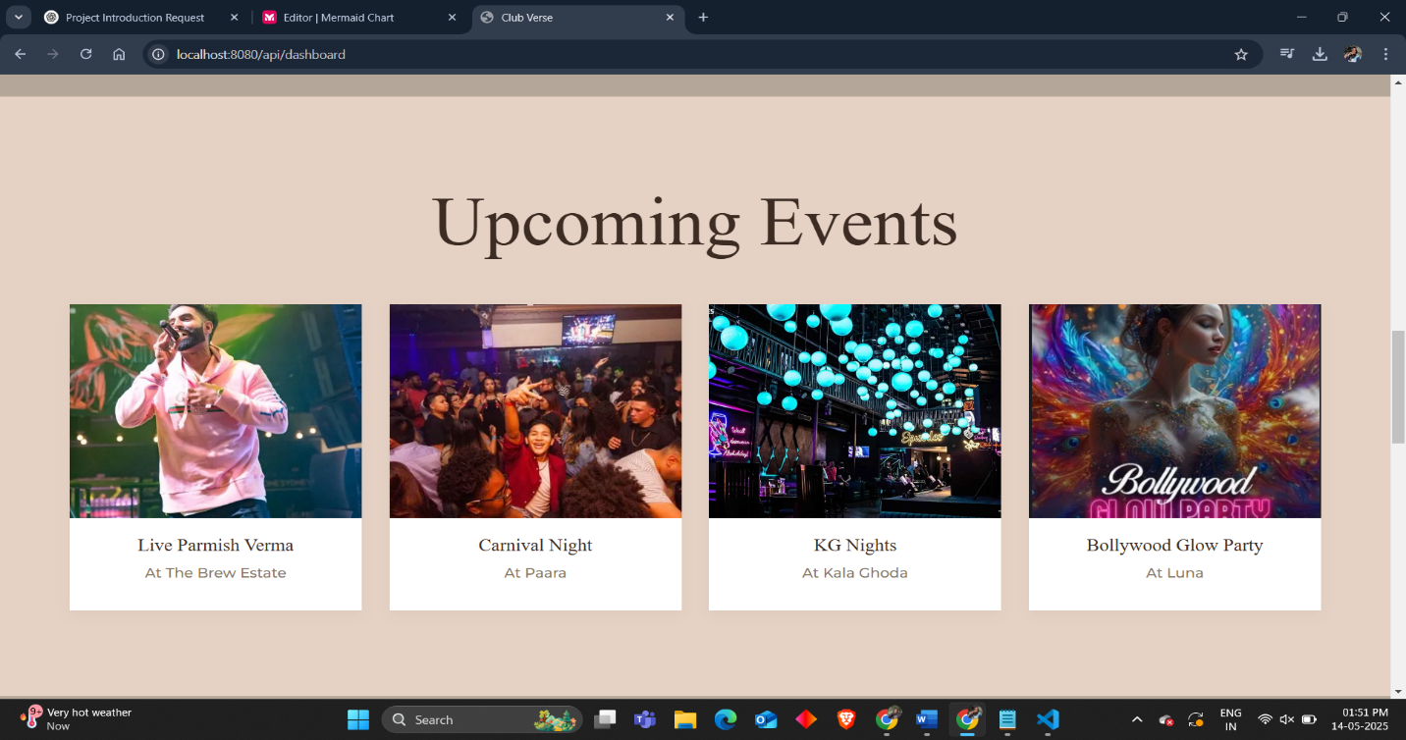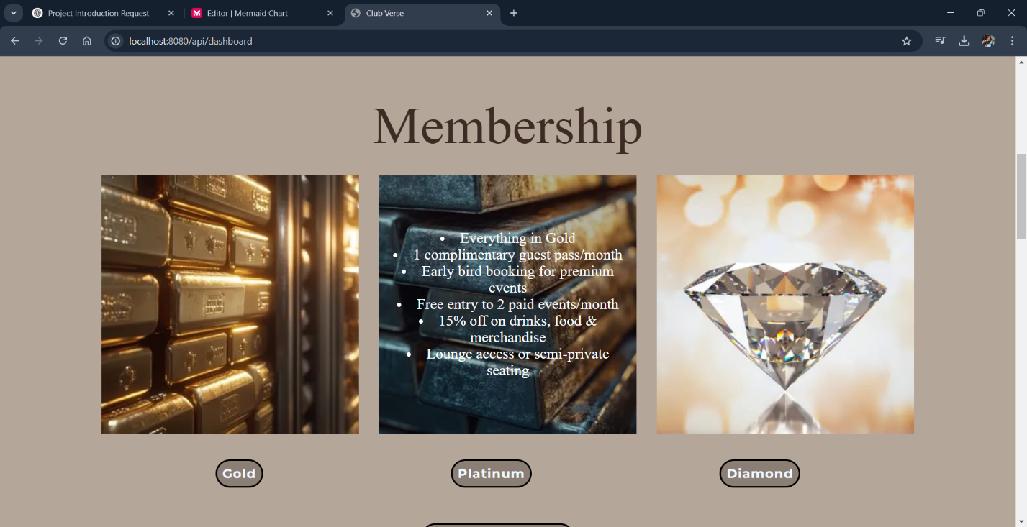**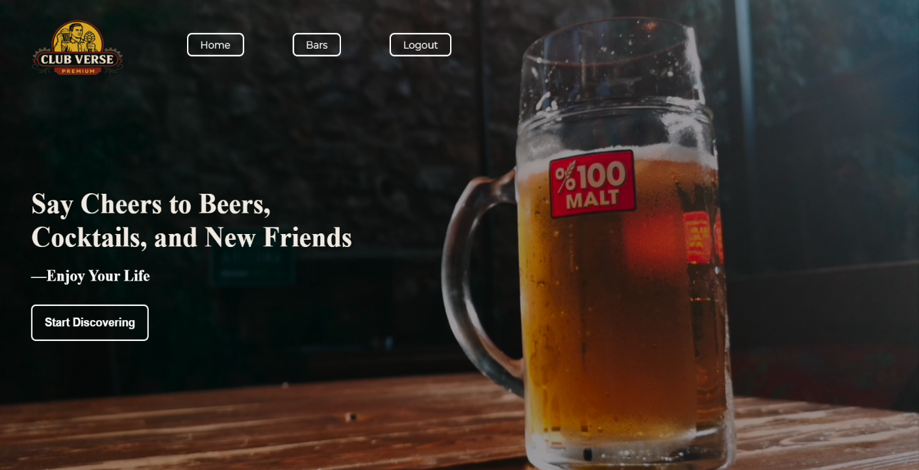4.3 Home page**

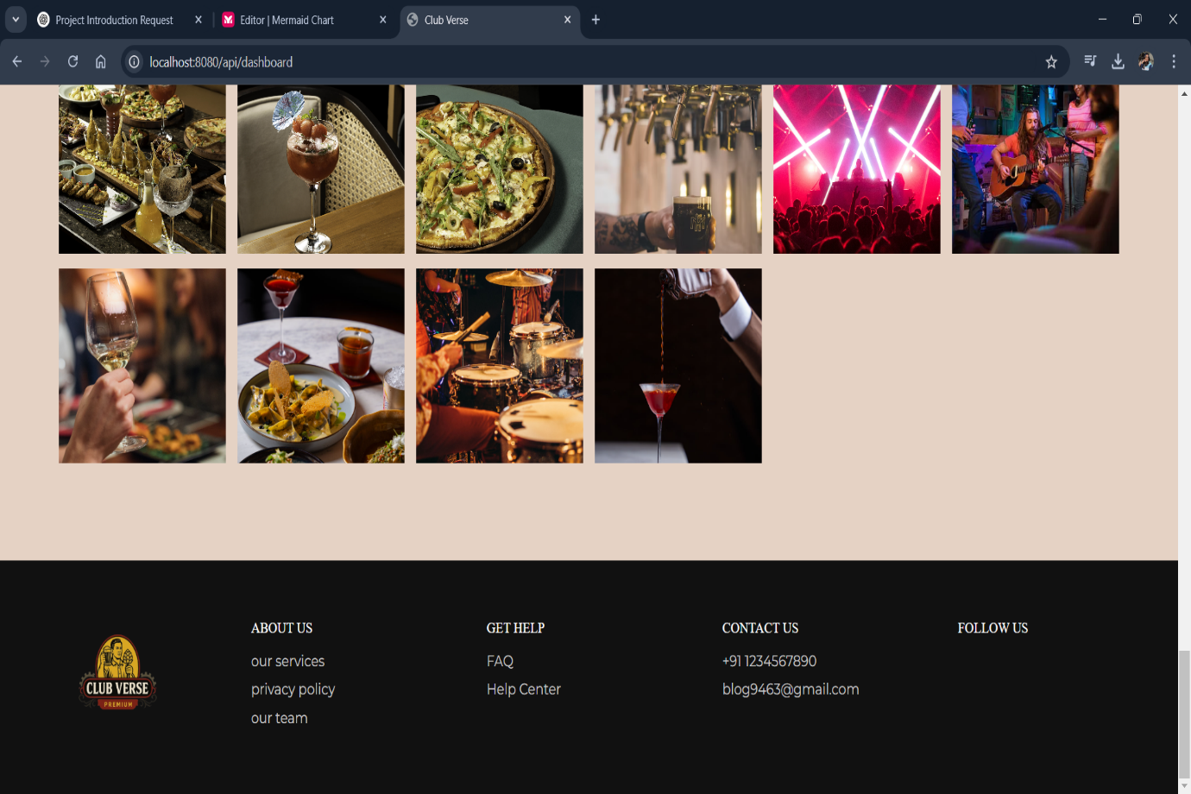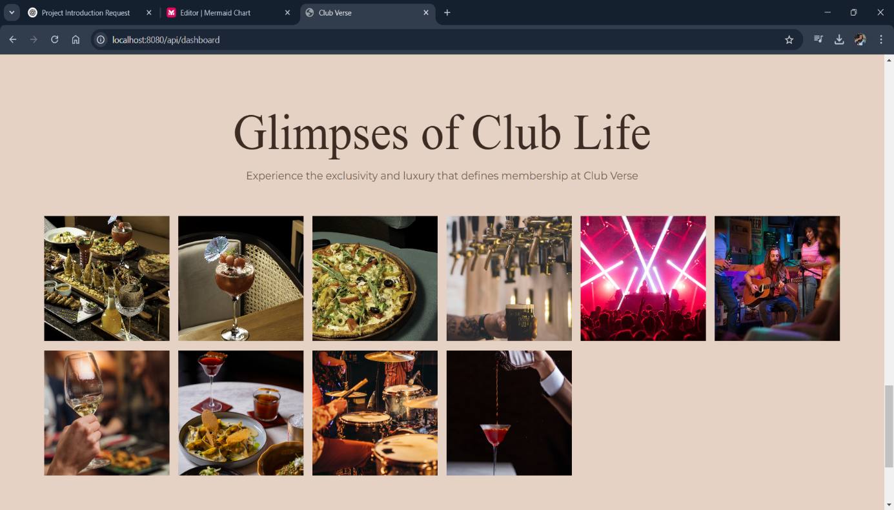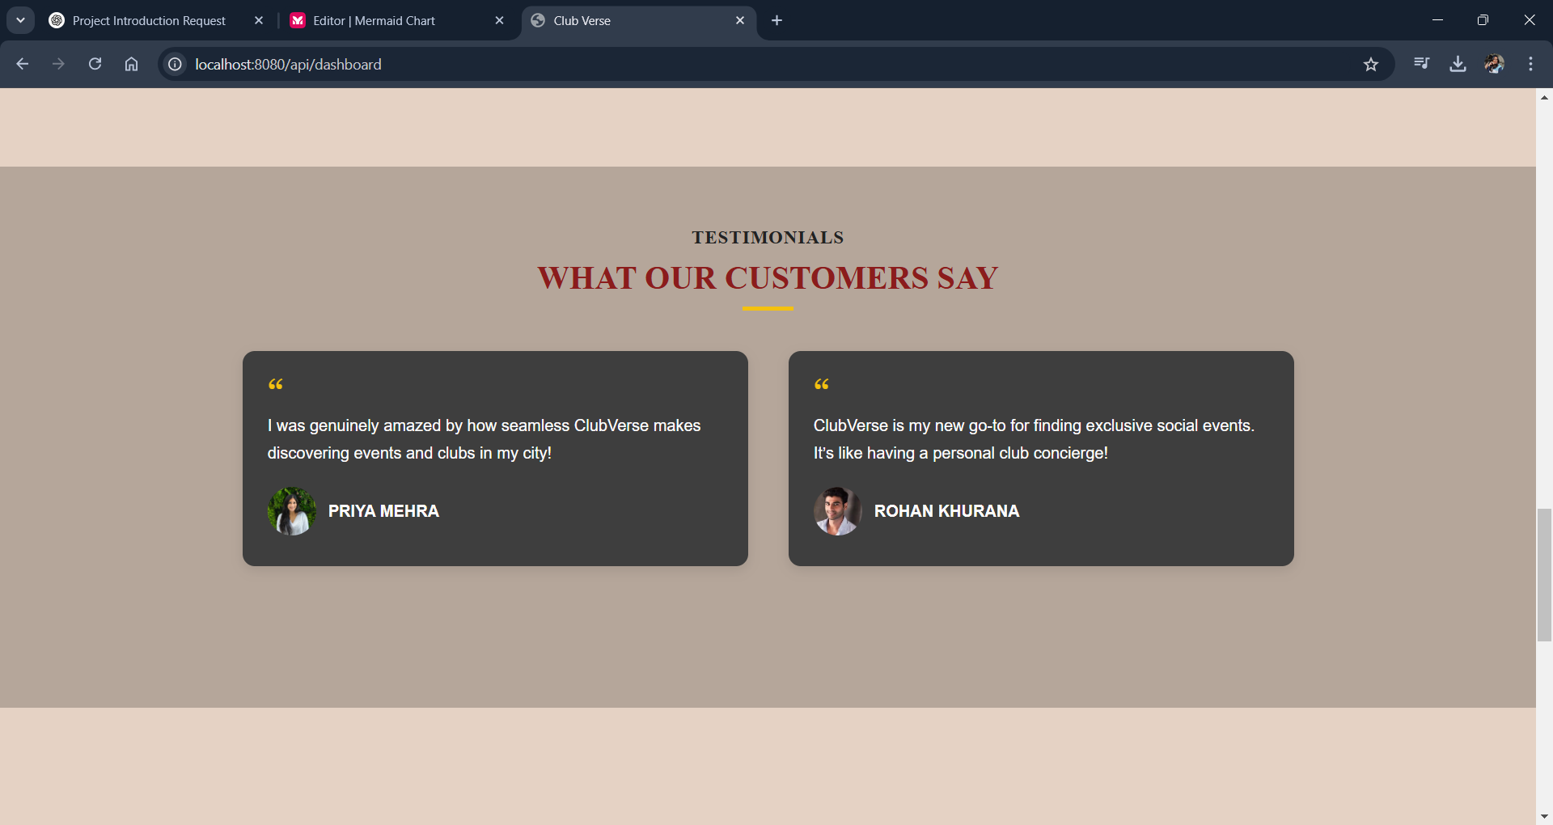

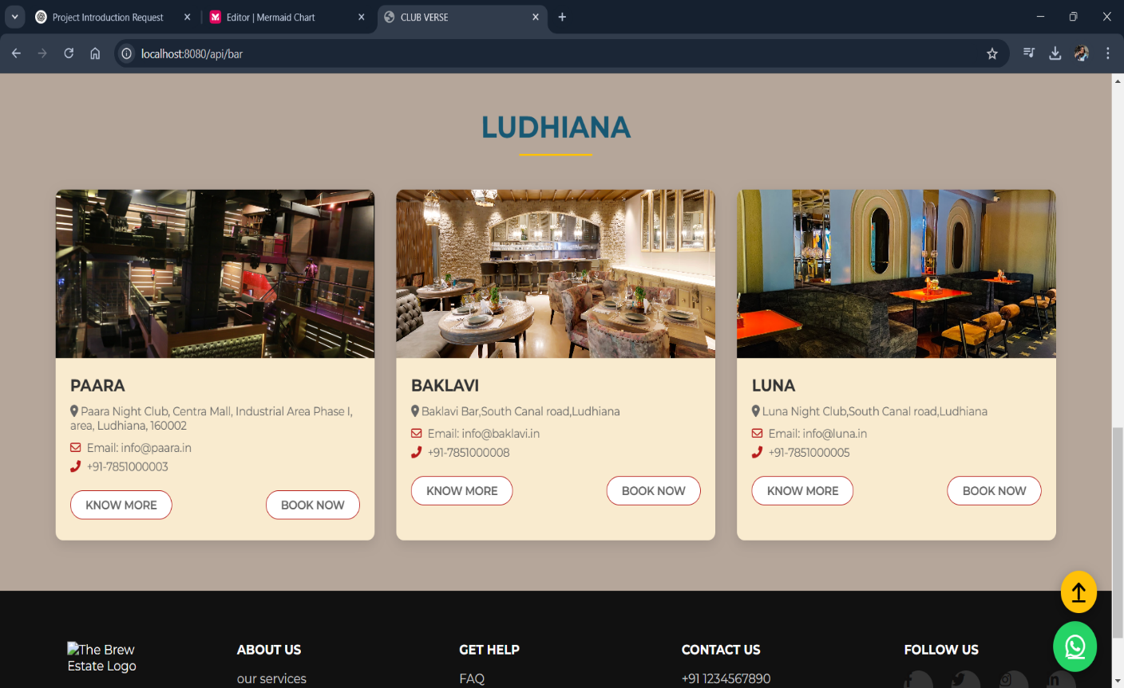**4.4 Bars Page** 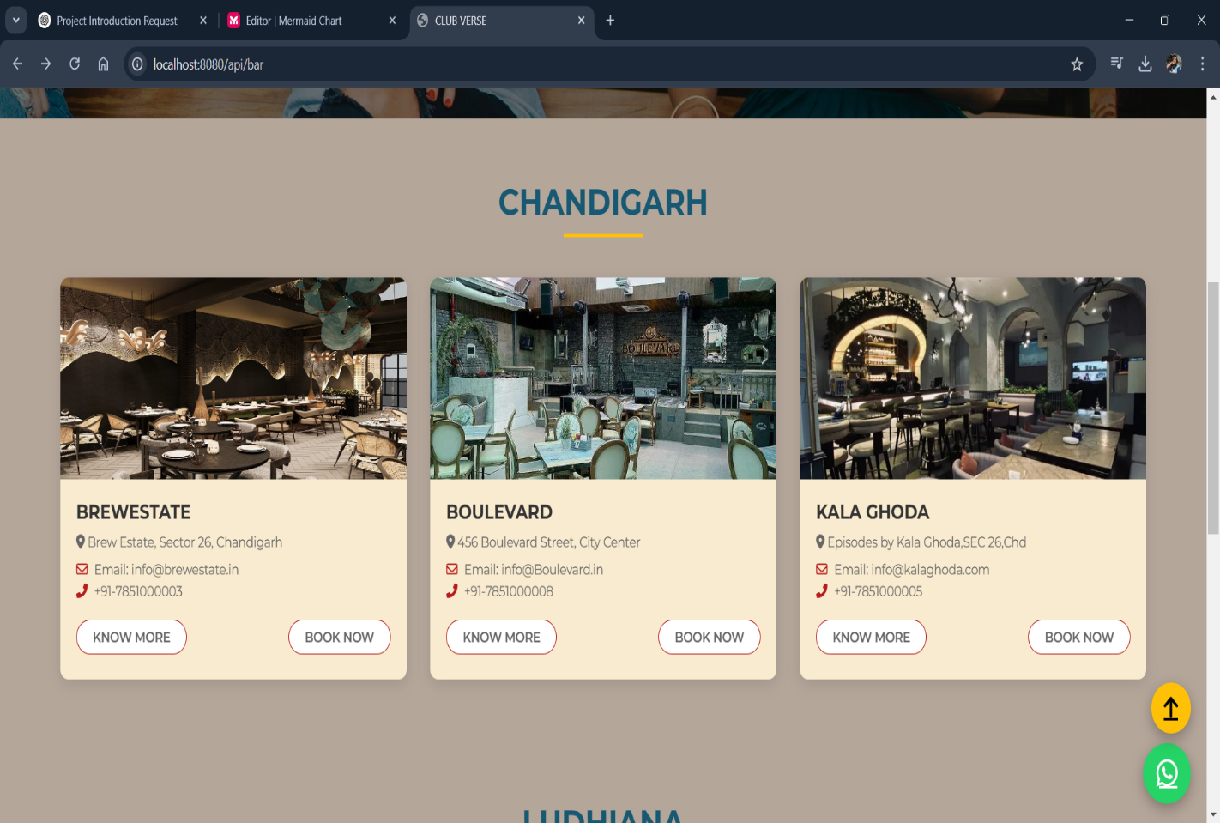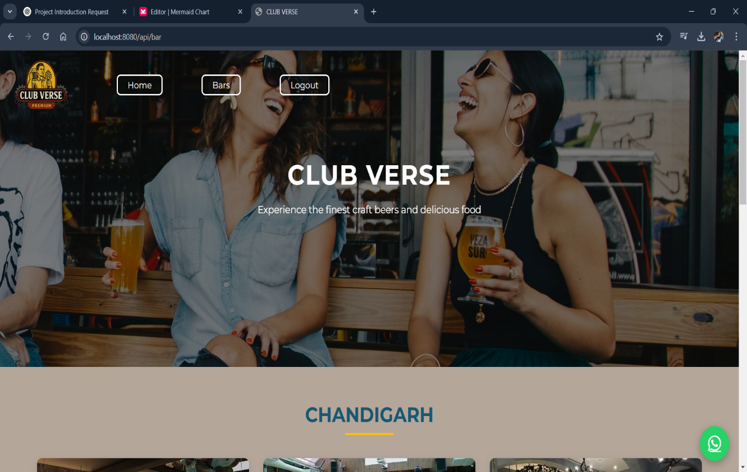

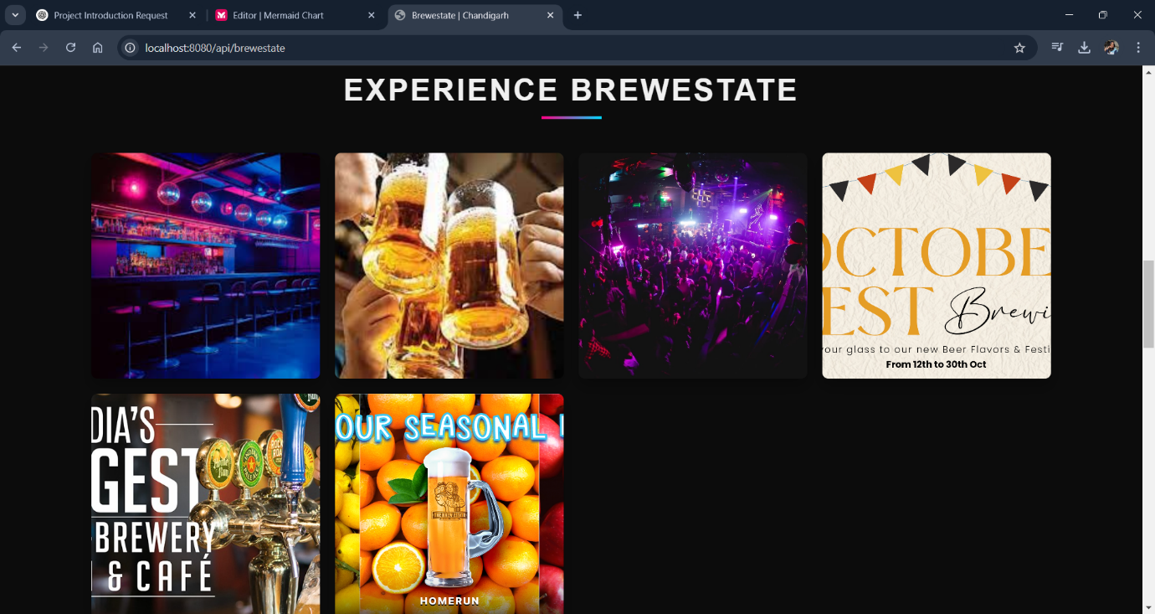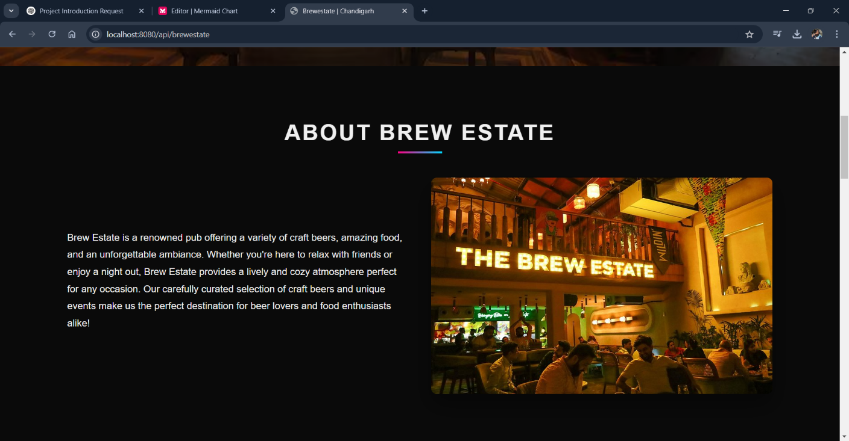**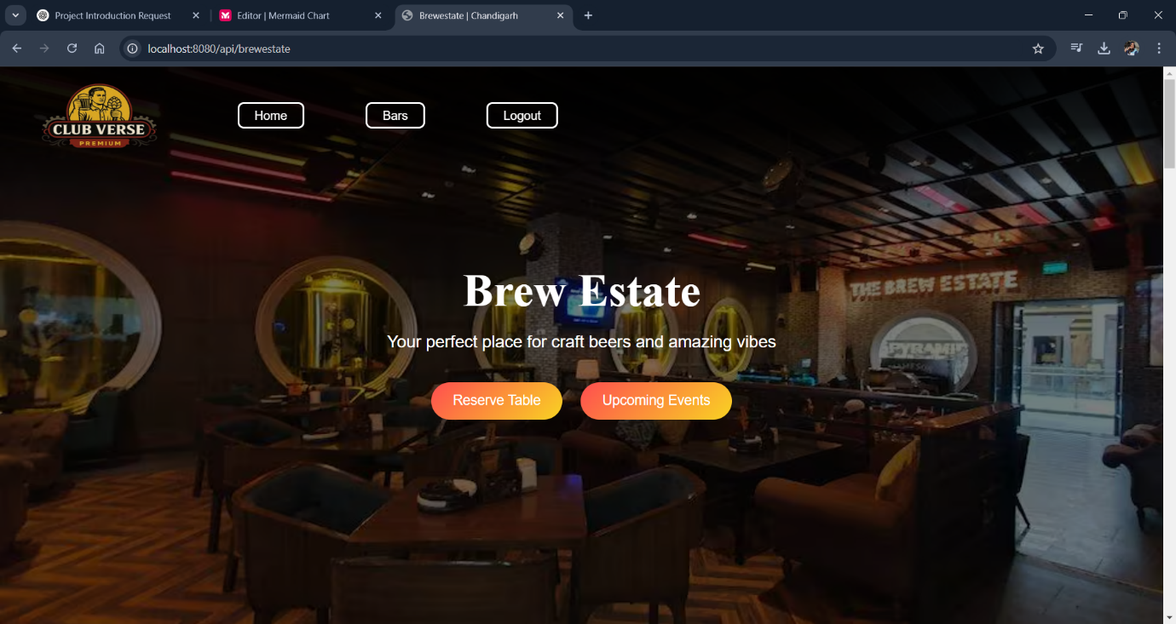4.5 Brew Estate Page**

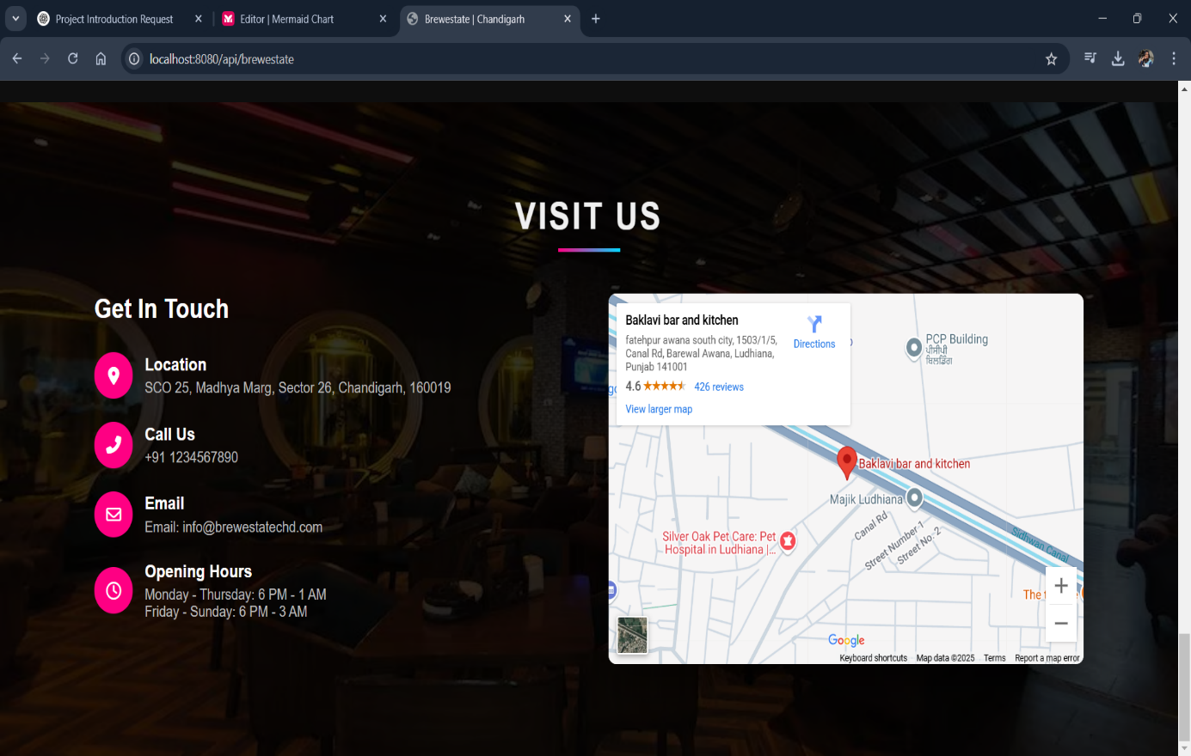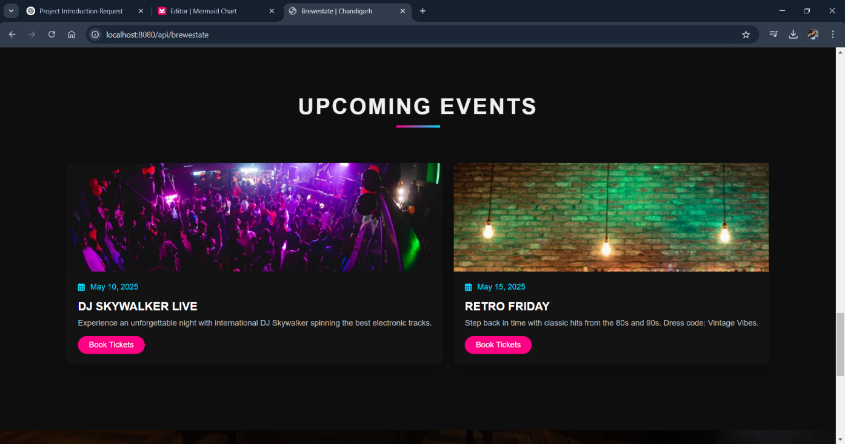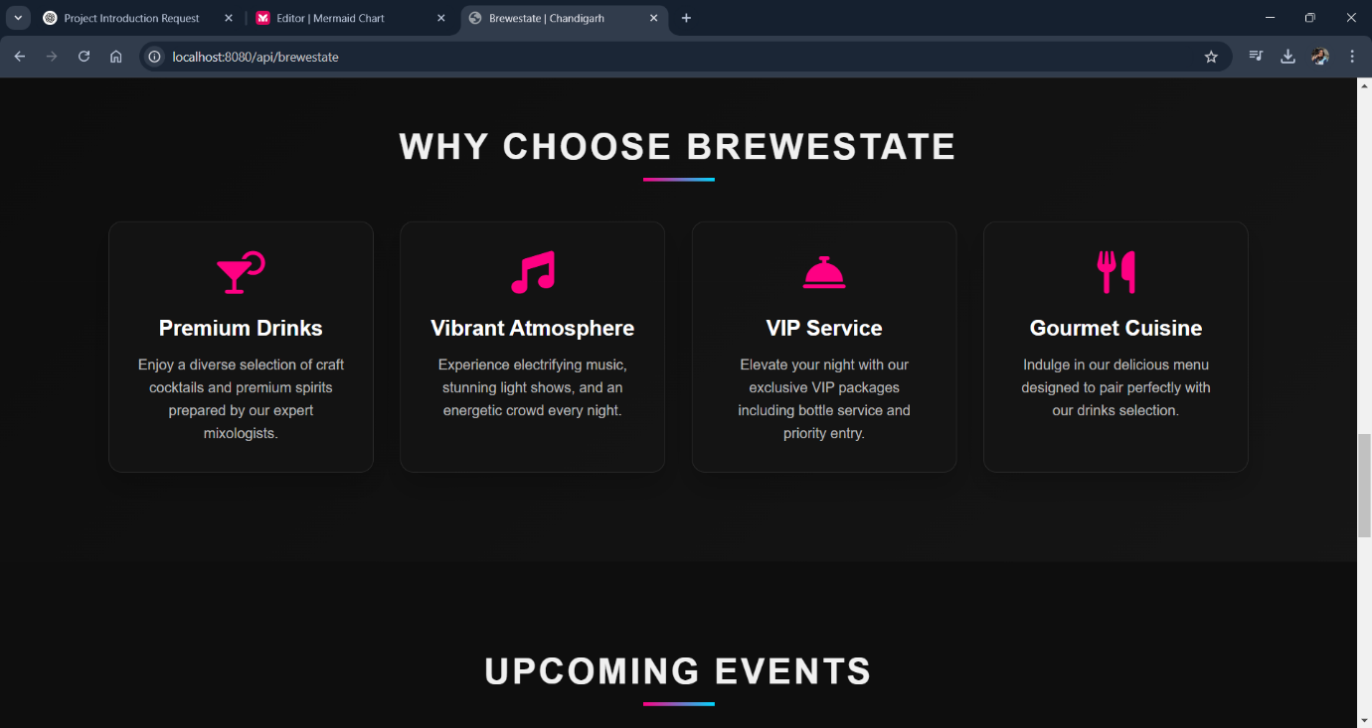

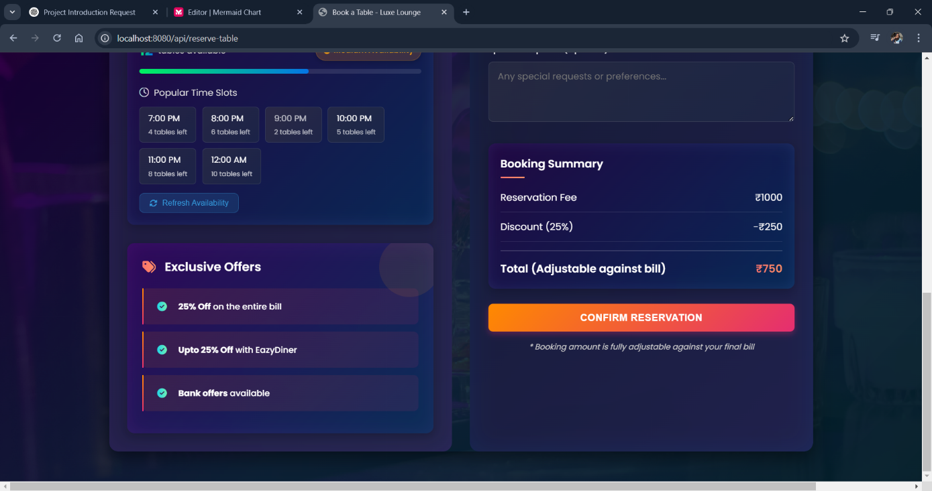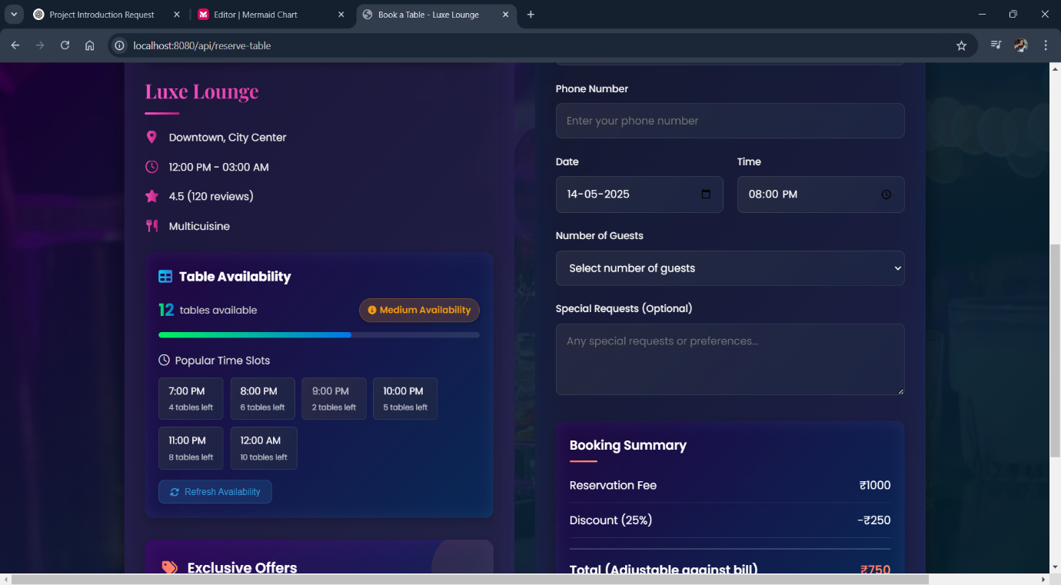**4.6 Book Now Page**

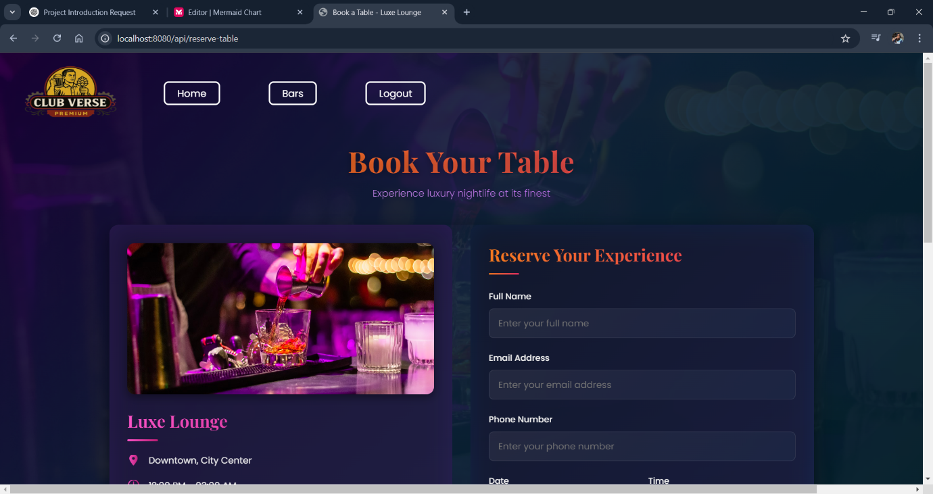

**5.REFERENCES**

https://nodejs.org/en/docs/

https://expressjs.com/

https://docs.mongodb.com/

https://mongoosejs.com/docs/

https://ejs.co/

https://tailwindcss.com/docs

https://newsapi.org/docs

https://fontawesome.com/docs

https://developer.mozilla.org/

https://api.artic.edu

https://gapsystudio.com/blog/marketplace-ui-ux-design/